AI Tools for Different Professional and Academic Domains
Software Development
Introduction
Software development is one major activity in the SDLC (System Development Life Cycle), which is a primary step done after necessary planning and analysis of a particular system. Software development is the process of coding, designing, documenting, and testing a particular program written using a certain programming language.
Software development can be divided into two main sections as below,
- Frontend Development
- Backend Development
How AI tools are used in facilitating software development
In the modern day, AI has been revolutionizing software development with the assistance of AI tools and techniques. Due to this, it has been able to increase the productivity, accuracy, efficiency, and innovativeness of the software that is developed. AI tools have also been able to support system testing with the newly developed software, which we will be discussing more widely below.
Frontend Development
The frontend of a software means the section of the software that the client or the user is interacting with, or it is the section that the user can see. This section contains text, audio, video, images, etc. There have been many AI tools that have been developed in order to make the front-end tasks much more convenient. Tools such as Cursor, GitHub Copilot, Windsurf, and Claude Code are mostly used nowadays. Here we focus on how the Cursor AI tool assists in the process.
Cursor: This is an AI-powered code editor and a software development tool that is somewhat similar to a modified version of Visual Studio Code. This tool has been developed by Anysphere. This tool provides developers with the ability to code, edit, and debug much more conveniently.
Unlike most of the AI-based editors currently available, Anysphere has been able to integrate AI into the core architecture of the tool Cursor rather than providing some features in the editor. Cursor provides the ability for coders not only to code but also in various other methods, like editing multiple files, predicting the next move of the coder, fixing errors, and also Cursor has the ability of reading the whole project to understand how the files are connected to fulfill the vision of the coder.
Many main companies like Nvidia, OpenAI, and Stripe are currently using Cursor for their software development activities.
Reference –
Cursor official website – https://cursor.com/
Builtin website - https://builtin.com/articles/what-is-cursor-ai
Backend Development
The backend is the hidden part of a certain website or any other software. This can also be called the backbone of modern software. This is the part where a user cannot touch or see. This is the part that is saved on servers and contains data related to the users and their accounts by saving and retrieving the saved data with the help of databases. In this section of software development, AI is also playing a major role by reducing the workload of the developers. AI has revolutionized backend development, leading it to a more efficient, reliable, and innovative perspective. Amazon Code Whisperer, LangChain, and Codium AI have been majorly facilitating backend software development. Here we will be focusing on Codium AI.
Codium AI – This AI tool has been developed by Exafunction, and this tool provides the ability to perform backend development activities faster and more efficiently with the help of coding, database model development, and debugging.
This tool assists the developer in generating backend tests and in finding bugs in backend logic and database-related development. This AI tool is also included with several major programming languages like Python, JavaScript, and Java. Due to the massive support provided by Codium AI for backend development, this tool is used by several companies to develop their own software, such as digital agencies and enterprise IT consultancies, cloud infrastructure providers, and financial enterprises.
Database Management
Another major section of software development is database development. This is where all the data of the users are stored in order to retrieve it efficiently and accurately when required. Therefore, managing all these large amounts of data is required to maintain the reliability of the software and the privacy of its users. With the development of AI, database management has become much more convenient for developers with the immense capabilities received from AI tools.
Supabase AI, DevOps Guru, and Ever SQL are some of the major AI tools that are currently used among developers. Here we will focus on how Supabase AI is used for database management nowadays.
Supabase AI: This AI tool is integrated with strong AI assistance, which is capable of providing solutions for any error or issue faced during database development. This tool is able to streamline the workflow of the developers significantly by reducing the time it takes for database development.
This tool has also been capable of providing comprehensive support in query generation and debugging. With the help of Supabase AI, developers can use natural language to generate complex SQL queries.
Reference for Supabase AI –
Supabase AI official website – https://supabase.com/features/ai-assistant
Medium - https://medium.com/the-agent-protocol/supabase-development-with-ai-agents-a-comprehensive-guide-to-automating-your-workflow-5cf0eda5bc16
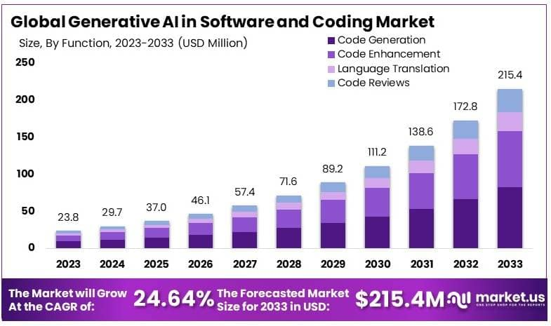
The bar chart here shows how the market related to AI in software development has been performing and how it would be around 2033. As per the analysis, the global market as of 2023 was $ 23.8 million; by 2026, the net worth is $46.1 million and is expected to reach $215.4 million by 2033. The main reason for this is the use of AI in IT and telecommunications and organizations related to it due to the reliability of AI and dominating code generation capability. As per the records, AI is currently used mostly in the American regions for code development and is expected to reach the complete world in the near future.
Reference –
Market.us - https://market.us/report/generative-ai-in-software-and-coding-market/
Advantages of AI influencing Software Development
- Ability to generate code much faster
- Assists in code reviewing
- Ability to detect bugs and errors at early stages and more conveniently
- Ability to perform debugging of the software easily
- Ability to manage large databases much more efficiently and accurately.
Disadvantages of AI in Software Development
- Reduces the job market for software developers
- Over-dependency on AI tools can cause a lack of skilled professionals in the software industry.
- Data breaches can be caused due to various intruder attacks
- High cost in the development of AI tools.
- Ability for the presence of hidden bugs in AI-developed software.
Responsible usage of AI tools in software development
To use AI responsibly, developers must not rely solely on AI in the development of systems and software, as it can introduce many vulnerabilities. Humans must always stay in touch with the developing system to ensure smoothness, user data privacy, and to debug any hidden bugs that might be present. Though AI has been well developed, we must all be very responsible in using it, as AI is an intelligent assistant and not an autonomous replacement.

Conclusion
AI has provided the ability to develop software much faster and more conveniently, but what is happening in the world is that developers are being replaced by AI; this can cause major impacts on technology and society, as there must be human intervention in order to control AI. After all, AI is a service provider, not a replacement, and human involvement is a must to it to prevent negative impacts on society.

